Cau 1

* How to check a variable’s type?

Check o phan assignment statement

* In what cases, you will get ***SyntaxError*** from the compiler telling you that some of your variables have **invalid names**? Can you give 3 different examples of **invalid names**?

3 VD

-Ten bien bat dau trung vs python(print,cd,...)

-Ten bien bat dau bang ki tu dac biet({,}@,%,...)

-Ten bien bat dau bang so(6,9,...)

Cau 2

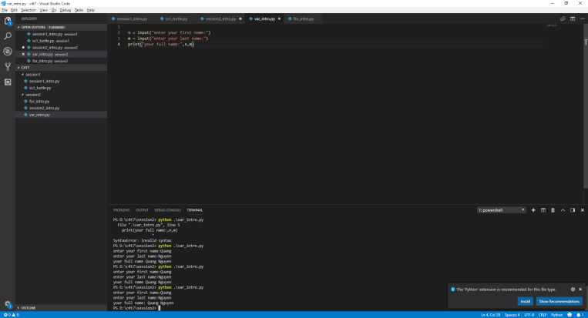

Cau 3

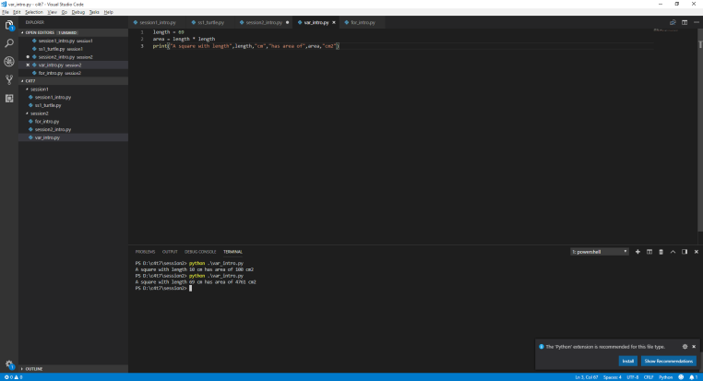

Ve hinh tron

Ve hinh tron

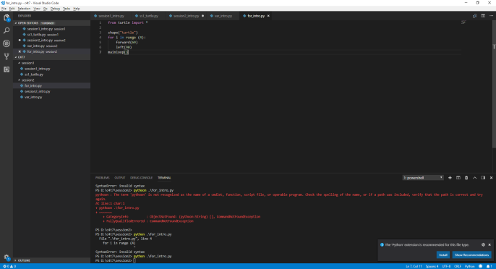

Ve hinh tam giac deu

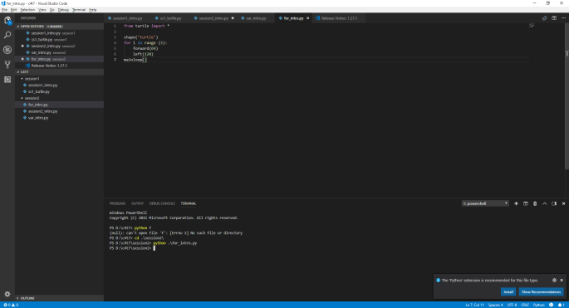

Ve hinh tron

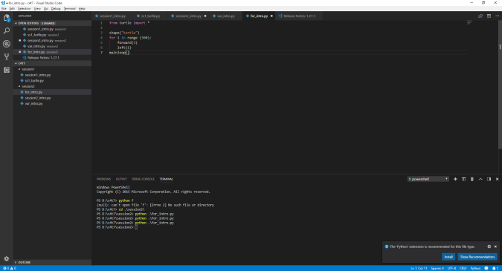

Ve nhieu hinh tron

